**Write pseudocode and flowchart for a program that outputs ‘True’ if a given number is divisible by 3 and ‘False’ otherwise, without using the ‘%’ operator explicitly (like N % 3 == 0).**

**NOTE:** You can use ‘%’ operator to separate each digit of the given number(like N % 10).

1. Declare Sum,Num,Rem as integer
2. Declare Result as string
3. Assign Sum=0
4. Input any number
5. If Num>=1
6. Then, Rem= Num%10
7. Num/10
8. Sum=Sum+Rem
9. else,
10. if Sum>0
11. then Sum-3
12. Else,
13. If Sum==0,
14. Print Result = “true”
15. Else Print Result = “False”

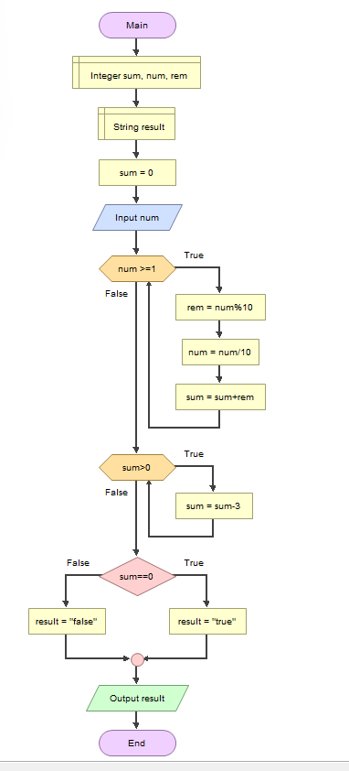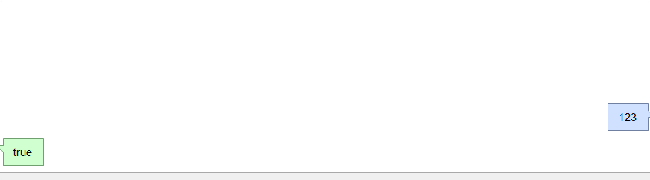

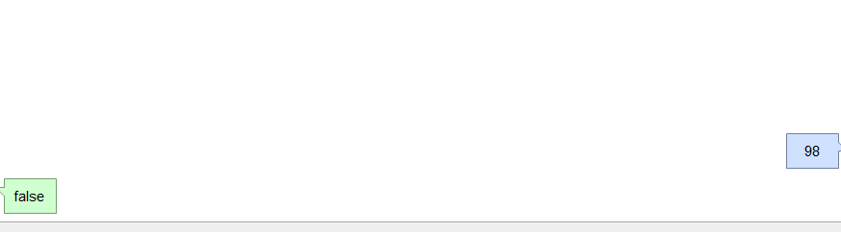

#### Write pseudocode and flowchart for program that prints Nth fibonacci number. (Nth Fibonacci Number denoted as F(N), F(0)=0, F(1)=1, F(2)=1, F(3)=2,…)

1. Declare num1, num2,num and i
2. Assign num1=0 , num2=0,i=0
3. Input any number
4. If i<num
5. Then, i = i+1
6. Num2= num1+num2
7. Num1= num2-num1
8. Else,
9. Print num1

